**How To Set Up GitHub & Jekyll Blog Instructions for PC**

1. **Setting up GitHub**
2. Create a free GitHub account <https://github.com/>. You can ignore the optional survey questions.
3. Go to the plus sign in the top right and select New Repo:

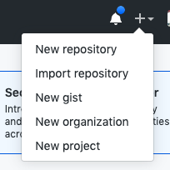

1. Name the repo “Rollercoaster” and make sure the “Initialize with README” box is **unselected**. Then press enter:

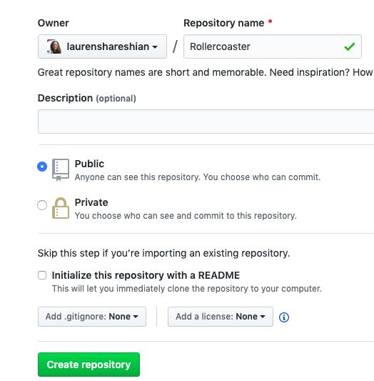

1. Keep this website open because you will use the info listed here in a little bit:

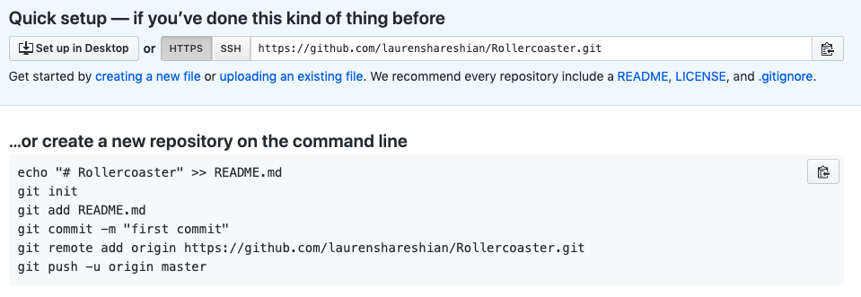

1. Download git for windows and run it. You can keep all of the default options the same:

<https://git-scm.com/download/win>

1. Now, on your LOCAL computer (inside Documents), create a folder called “Machine_Learning” (with an underscore in between). Within that folder, create a folder called “Rollercoaster”. Put your rollercoaster Jupyter Notebook analysis file inside of this. (You may need to first download this from cocalc).
2. Then, go to Start Menu and search “Command Prompt” to open up a terminal.
3. If your Rollercoaster file is located within your Documents, you will type “cd Documents/Machine_Learning/Rollercoaster” or if it’s within your Desktop, type

“cd Desktop/Machine_Learning/Rollercoaster”

1. Type “dir” and press enter to see your present working directory. It should end in Machine_Learning/Rollercoaster**. If it doesn’t, come find me before proceeding.**
2. Now, copy and paste each line listed on the GitHub website one at a time, pressing enter in between. **THESE LINES MUST BE TYPED EXACTLY. IT IS HARD TO FIX MISTAKES IN GITHUB SO PLEASE TRIPLE CHECK BEFORE PRESSING ENTER. IN PARTICULAR, IN THE “REMOTE ADD ORIGIN LINE”, IT WILL SAY YOUR USERNAME INSTEAD OF MINE:**

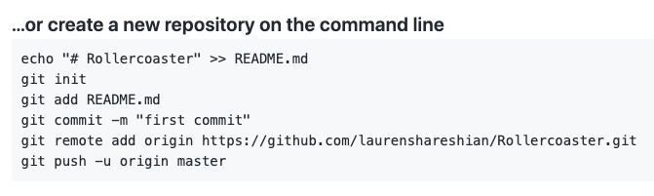

(You will probably need to enter your GitHub username and password using these lines):

git config --global user.email [laurenshareshian@gmail.com](mailto:laurenshareshian@gmail.com) (your username)

git config --global [user.name](http://user.name/) "Lauren Shareshian" (your name)

1. Refresh this website and you should now see your Rollercoaster code listed on the website.
2. **Okay, now we can use Jekyll with GitHub to get a blog site working.**
3. In your terminal, type “cd..” to get out of your Rollercoaster directory.
4. Type “dir” to confirm that you are in your Machine_Learning directory. If you aren’t, get there.
5. Go to <https://github.com/barryclark/jekyll-now>
6. In the top right, select “Fork this repo”.

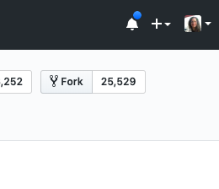

1. Go to settings, and rename the blog “yourGitHubUsername.github.io”. For example, I will rename mine “laurenshareshian.github.io” but yours will be different:

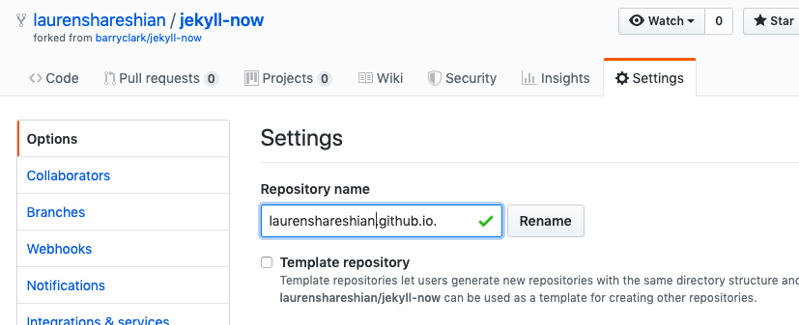

1. Your website should now be viewable at <https://yourgithubusername.github.io> (change the username to yours).
2. Then type (after replacing “yourusername” with your username in both places):

git clone https://github.com/yourusername/yourusername.github.io.git

1. Go to Notepad and open the file “_config.yml” located under Machine_Learning/yourusername.github.io/
2. Edit your name, description, and avatar. To update your avatar, place a picture of yourself inside the Machine_Learning/yourusername.github.io/images folder. Suppose your image is called “me.png”. Then you would change the following text (not forgetting the extra slash) to:

# URL of your avatar or profile pic (you could use your GitHub profile pic)

avatar: /images/me.png

1. Save this _config file.
2. Go back to your terminal and carefully type: (with enter in between)

git add -A

git commit -m ‘changed info’

git push

1. If you wait 15 seconds or so and refresh the website, you should see these changes reflected.
2. **Creating a Rollercoaster post:**
3. All of your posts will be located in the folder Machine_Learning/yourusername.github.io/_ posts. Look at the Hello World one located there. Notice that you ALWAYS need to start the post filename with the date in that form. You can copy the Hello World file and resave it as “2019-09-19-Rollercoaster-Project.md”.
4. Edit this file with a few sentences about your rollercoaster project inside TextEdit. Also, add in a picture of a rollercoaster. To do this, save a photo as coaster.png and put it inside the Machine_Learning/yourusername.github.io/images/ folder.
5. Then, in your “2019-09-19-Rollercoaster-Project.md” file, type:

<img src="/images/coaster.png" width="600"/>

1. Save this file. Then, type carefully (with enter in between):

git add -A

git commit -m ‘created rollercoaster post’

git push

1. Wait 15 seconds or so and refresh the website. You should now see a new post.
2. You can now edit the blog as you wish. Each time you save the changes to your local computer, you’ll then want to do the git add/commit/push lines and refresh the website again. **BE SURE THAT YOU ARE ALWAYS INSIDE THE Machine_Learning/yourusername.github.io/ DIRECTORY (BY FIRST TYPING PWD TO CONFIRM) BEFORE YOU DO THIS, OR ELSE YOU CAN GIVE YOURSELF A BIG HEADACHE.**

To check out some examples of summarizing your projects, you can read mine:

<https://laurenshareshian.github.io/>

You can also find a gazillion examples of way cooler layouts here: [www.jekyllthemes.org](http://www.jekyllthemes.org) and here [www.jekyllthemes.io](http://www.jekyllthemes.io). And tutorials here: <https://jekyllrb.com/resources/>